NAAN MUDHALVAN

NAME:GANESH PANDIYAN

COURSE:SALESFORCE

NM ID: **0E0C93099B02554B8654F55A558B0111**

Task1:

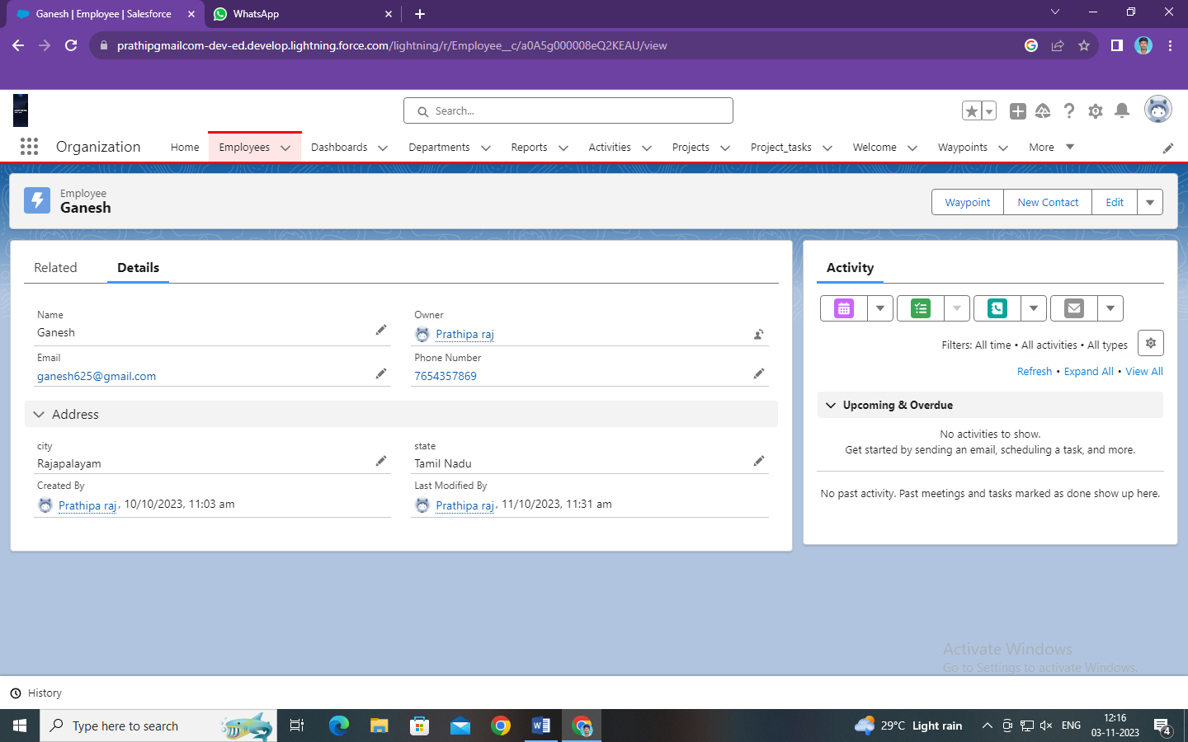

Task 2:

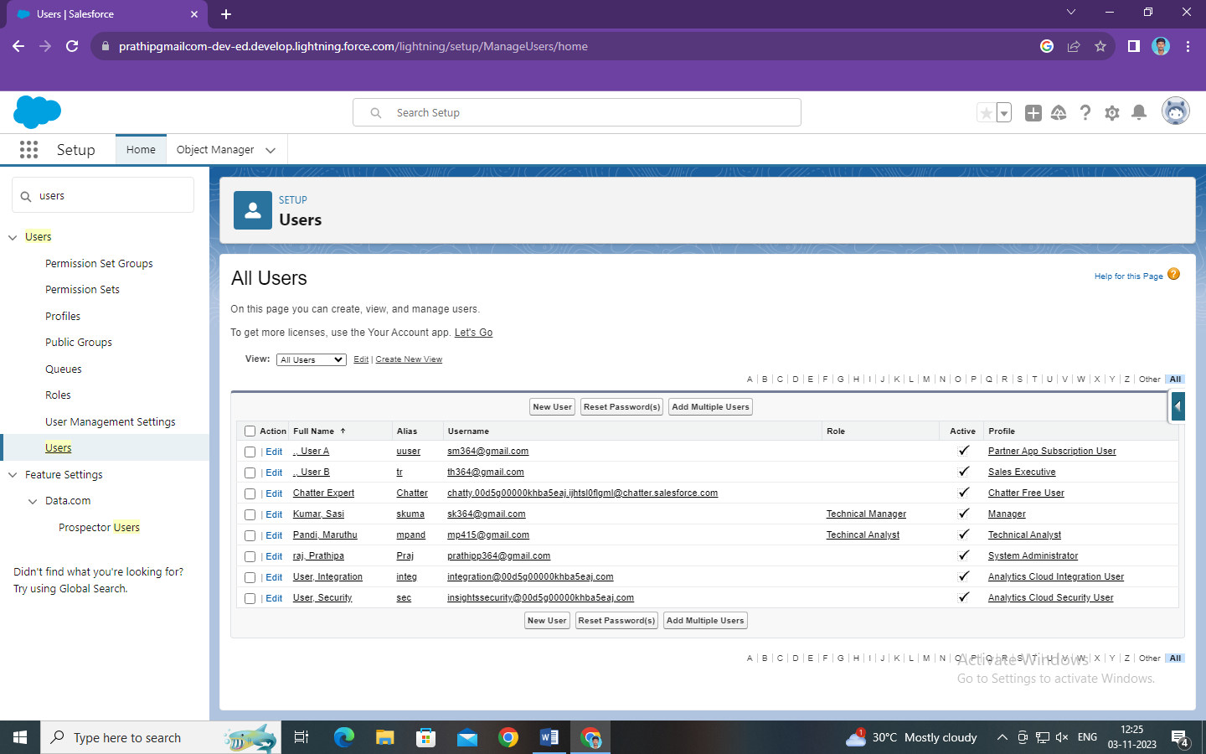

Task 3:

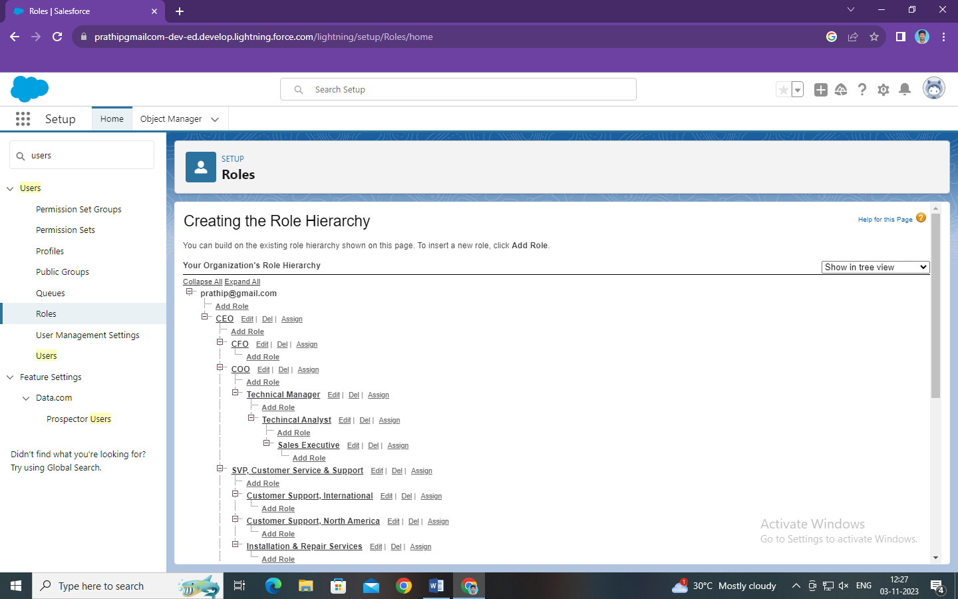

Task 4:

